 

# Online Second Hand Book Buying and Selling Portal

## By

**Prasad Rathod**

## Reg. No. /Roll No: MCA21033

A Project Report Submitted to the University of Mysore In *partial fulfillment of the*

*Requirements of 4th semester MCA degree examinations 2022-2023*

UNIVERSITY OF MYSORE

Manasagangothri,

Mysore– 570006

 

# Online Second Hand Book Buying and Selling Portal

## By

**Prasad Rathod**

## Reg. No. /Roll No: MCA21033

A Project Report Submitted to the University of Mysore In *partial fulfillment of the*

*Requirements of 4th semester MCA degree examinations 2022-2023*

UNIVERSITY OF MYSORE

Manasagangothri,

Mysore– 570006

**1. INTRODUCTION**

The online practice of consumers making direct purchases of products, services, etc. from a seller in-person or online without the need of a middleman.

The act of purchasing goods and services via internet vendors is known as online shopping. Merchandisers have tried to sell their books to Internet users ever since the World Wide Web first appeared. Customers can look through internet stores while lounging in front of computers at home. Customers purchase a wide range of goods from online retailers. In reality, businesses that offer their books online allow customers to purchase almost everything. Aside from the hundreds of books available to customers at an online store, They can also buy clothing, furniture, toys, equipment, software, and health insurance, among other things.

The act of purchasing goods and services via internet vendors is known as online shopping. Attempts to sell books to Internet users have been made by merchants since the World Wide Web's inception. Online shoppers can browse stores while lounging in front of laptops at home. Customers buy a variety of products from internet merchants. Customers can actually buy nearly anything from companies that sell their books online. Customers at an online store can buy apparel, furniture, toys, equipment, software, and health insurance in addition to the hundreds of books that are offered.

**1.1 : Background:**

You may browse through countless options and find goods that are unavailable in stores when you shop online. If, however, you are seeking for a specialty item that might not be available locally, you can be sure to locate it online. The capacity to compare details online, whether they are comparable or not, is actually more valuable. You may compare the material quality, sizes, and prices while simultaneously searching across multiple stores.

Bid adieu to the times when you had to wait in line for a store clerk to eventually check your information by waiting, staying, and waiting some more. Your time is effectively saved by online sales, allowing you to complete other errands. Additionally, competent customer support agents are available 24/7 when buying online, unlike in physical stores. Every day of the week, to assist you in finding, picking up, and shipping your goods.

**1.2 Objective:**

My dream is to create a system that allows people to bid farewell to the times when they had to stand in line, wait, and then wait some more for a store clerk to finally look over their information. Online sales successfully free up your time so you can complete your other errands. Additionally, professional customer support representatives are always on hand when purchasing online, in contrast to traditional stores. Every day of the week, to assist you in finding, picking up, and shipping your goods.

My major goal is to create a book store where customers can come in at any time of day from anywhere to see the selection, pick a book, and place an order by paying online or by cash on delivery. Any new books that become available for trade will be continuously added by the director. Only books from reputable publishers and merchants will be accepted by the director.

**1.3 Purpose and Scope:**

**1.3.1 Goals:**

Provide a web-based user interface for adding, viewing, and deleting records in various regions.

• allow a stoner to input computer information via an interface.

• give users of all the computers and accessories a user interface via which they may change the settings.

• offer a stoner interface so that drug users can browse the store and choose particular items to purchase.

**1.3.2 Scope:**

**The main objectives and results of the design would be to:**

Identify and create accurate requirements and specifications:

Create thorough design standards for the system in high positions; • Create test plans and test cases; Create the rendering and system

**Achievements**:

By successfully enforcing the design, a significant amount of knowledge about the implementation of a database system using internet technologies has been gained. This knowledge will come in handy when developing any kind of desktop application or online database systems in the future.

**Achievements**:

By successfully enforcing the design, a significant amount of knowledge about the implementation of a database system using internet technologies has been gained. This knowledge will come in handy when developing any kind of desktop application or online database systems in the future..

**Technology, Innovation and Support:**

Since business and technology are intertwined, technological leadership is the most effective tactic for fending off competitors and solidifying our position. The conviction that this confluence exists within our organization has inspired and enabled us to produce results with a clear competitive advantage. Currently, GUSTOVILLEY Software Solution is a new frame of technology innovators to speed up growth.

In every design, we put a lot of importance on inventiveness. Our well-organized platoon uses a method and knowledge to start and deliver first-rate services. We are dedicated to provide software and high-tech firms with the necessary structure and tech support capabilities at a low price from our cutting-edge development centers based in Belgaum and Hubballi, India. Among the many biographies we provide are those of design directors, design leads, specialized leads, and software masterminds. We provide team leads, senior, and junior technical support labor force on a 24 x 7 basis for the support side.

**2: Literature Survey:**

There are several platforms, languages, and fabrics to pick from in a desktop application like Laboratory Management System. The following considerations, which are unique to windows grounded operations like this one, have been made before choosing from this wide range of technologies:

• Confirmation of data

• Performance

• Scalability

• Security

• Portability

• Trustworthiness

• Time Constraints

• Cost Constraints

**2.1 Existing System and Propose System:**

**2.1.1 Existing system:**

• Lack of interaction between buyers and sellers

• Lack of touch and feel of goods when shopping online

• Online shopping frauds.

**Draw backs:**

• The client in the Being System completely relies on the handcrafted purchasing procedure.

• Homemade methods take time to complete.

• And when a customer approaches for a homemade purchase directly, in reality

• he or she has no understanding of the outcomes, such as price range, specifics, etc.

• The time a customer spends on a homemade purchase can be compared to a number of purchases. A

• client can browse quickly while sitting at home.

**2.1.2 Proposed System:**

**Customers may go to the online web site for the following reasons:**

• Users can sell their used books fast.

• The practicality of online payment processing.

• Users may be able to more easily manage their book inventories as

**Advantages:**

• It saves time and money for stoners to spend.

• It will enable the stoner to resolutely create a new train via the internet.

Each schedule can be monitored in this system from the beginning ofthe Project cycle until its conclusion.

• The operation comes equipped with colourful controls and stoner generosity.

The method greatly simplifies and expands the flexibility of the whole book operation.

**2.2 The following are the numerous technologies that are available for consideration: System of operation: Windows 7**

**Languages used for client-side scripting include:**

• HTML

• CSS

• JavaScript

**as opposed to server-side scripting languages**

• PHP

• My SQL

• Apache for testing.

**Other programmers used include:**

• Xamp Server

• Adobe Photoshop

• Adobe Dreamweaver.

**2.3 Other Technologies and Tools:**

**HTML:**

Hyper Text Markup Language, or HTML, is the main lux language used to generate web pages.

written using HTML primitives, which are angle class-encircled markers ( like). Most HTML markers, like and, are used in pairs. However, some markers, like the end label, are mismatched because they signal empty rudiments. The launch label, on the other hand, is the first label in a brace ( theyare also called opening markers and closing markers).

Reading HTML pages and composing them into visual or audio web runners is the goal of a web cyber survey. The web surfer uses the HTML markers to comprehend the content of the runner but does not display the HTML markers. HTML is a luxury language rather than a programming language because it provides semantic hints for donation as well as describing the structure of a website.

The fundamentals of HTML serve as the foundation for every website. HTML makes it possible to include images and objects, and it may be used to make interactive forms. By defining structural semantics for textbook-like features including headings, paragraphs, lists, links, quotations, and other characteristics, it offers a technique to generate structured publications. It is possible to use scripts created in languages like JavaScript that have an impact

**CSS:**

In order for Web developers to specify the appearance and feel of their Web

applications, CSS was initially created in 1997. It was designed to provide creators the freedom to isolate content from design so that HTML could continue to serve the purpose for which it was initially developed— to give users the luxury of material without having to worry about its appearance or organization.

CSS didn't become more popular until around 2000, when Web users began using it for features more than simply the fundamental font and colour characteristics.

Web designers and developers who do not employ CSS for their website design and development are quickly becoming obsolete. And it's debatably just as crucial to comprehend CSS as it is to understand HTML—some would even argue that CSS knowledge is more crucial.

Style distance applies to the actual document. Style wastes have long been employed in document design. They are the exact guidelines for a layout, whether it is printed or displayed online. To guarantee that their designs are published precisely to specs, publish competitors utilize style wastes. The same function is served by a style distance for a Web runner, but with the additional functionality of instructing the viewing device (the Web cyber surfed) how to render the page being viewed.

**My SQL:**

The company Oracle Corporation created, distributed, and it provides supports this software and well advanced to creating software’s.

most recent information regarding MySQL software is available at the MySQL Web page (http://www.mysql.com/).

**PHP:**

Rasmus participated in the subsequent performances and served as inspiration for the original

PHP adaptation. This language is interpreted and lacks a compiler.

• The garcon carries out PHP law.

• Lot of databases, like oracle, my sql database are compatible with it. A content management system like Word Press is essential since it may be used to restrict access for stoners.

• All of the popular protocols, includes IMAP, FTP, HTTP Basic, HTTP Digest, and others, are supported. Yahoo.com and Facebook.com are two additional websites that use PHP.

• One of the primary causes of this is that PHP can easily be bedded in HTML lines, and

PHP trains can also write HTML canons.

**Xamp Server:**

The open-source web results contain the Apache distribution for numerous servers, command-line executables, and modules for Apache garcon, MariaDB, PHP, and Perl.

As was already mentioned, XAMPP serves as a symbol for the classification of technological solutions. It offers a framework for testing programmers made using various technologies and a personal server. The letters that stand for each of its essential components are combined to form the acronym XAMPP. This category of programmers includes the Apache web server, the MariaDB database management system, as well as Perl and PHP programming languages. It can operate on many various operating systems, including Windows, Linux, and macOS, if it is cross-platform, or X.

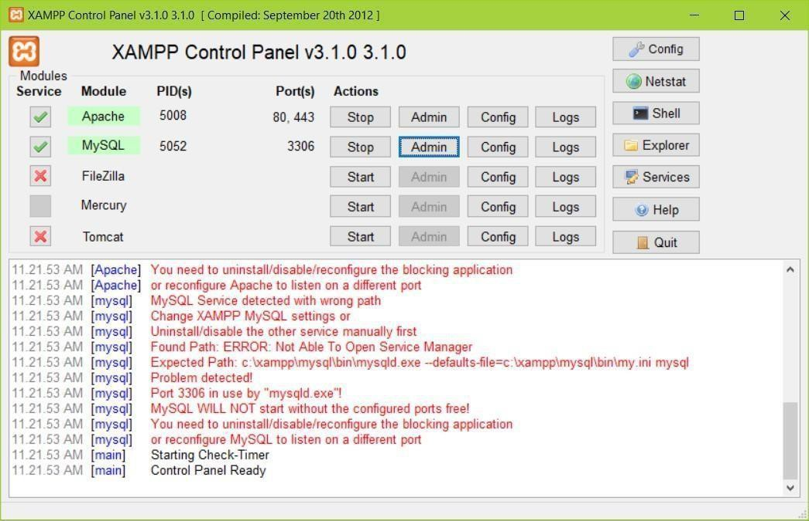

**Fig: Xamp Server**

**Implementation**

**I. Database overview:**

The online bookstore database sit on the Oracle is made of 4 tables.

**Fbooks:**

Define the inventory of books. It has the fields of: ISBN(primary key), Title, Author, ImageType, Price, Publisher and NumberInstock.

**Fcutomers:**

It saves all the information of the customers. It has the fields of: CusomterID(primary key), User, Passwd, Fname, Lname, Address, City, State, ZipCode, Phone, Fax and Email.

**Forders:**

It has the order information. The fields are: OrderID (primary key), CustomerID, TotalPrice, OrderDate, CardName, CreditCard, CreditType and ExpDate.

**Forderdetail:**

It saves the information of every books on a multiple book order. The fields are: OrderID, ISBN, Quantity and ShipDate. Primary key is the combination of OrderID and ISBN.

**II. Java class file overview**

This project consists of a total of 13 java files.

**BookDetails.java**

Define the object for an individual book. Every book has ISBN number, the Title and Price.

**ShoppingCartItem.java**

Every shoppingCartItem holds an object, which is a book and the quantity of the book.

**ShoppingCart.java**

ShoppingCart is implemented as a hashtable which can hold a book in ShoppingCartItem and number of different books in the hashtable. Add method is to add one ShoppingCartItem into the hashtable. Remove methold remove one from the hashtable.

**Cashier.java**

Cashier class hold an object of shoppingCart and has the method to calculate the total price of all books in the shoppingCart plus the tax(if any).

**BookpoolSearch.java**

This class worked as a bridge between the client's query and the online bookseller Bookpool.com. This can handle cilent's search by title and by author. After getting client input either by title or author, a query in the format of URL string is generated and sent to bookpool.com using java's standard URL class. Bookpool.com will respond to this query by returning a long string of html source code containing books of their database matching the query provided by the client. Boolpool.com returns 25 books in a single page, so the goal of this class is to parse all the useful strings from this long html source code which including the books ISBN, title, price and availability. After getting all these strings, regenerate another html code including all the book infomation and display on client's screen using Java Servlet.

**FatbrainSearch.java**

Another bridge class works similar to the BookpoolSearch.java. It will connect to the online bookseller Fabrain.com. This can handle the user search query by title, author, subject and publisher.

**BookSearch.java**

This class handle client's query to search the local Oracle database by Title, Author, ISBN and Publisher using Java JDBC. And using Java Servlet to generate html source code to display on client's screen. ShoppingCart was implemented by the Servlet Session Tracking technology. It takes the input from the bookstore main page, generates the searching query, searches the database and pastes the book found to user's screen. User can add any displayed books into the shopping cart by pressing the 'add to cart' icon.

**ISBNSearch.java**

This class handles client's query to search by ISBN and display detailed book information for the user. This include the full title of the book, the image of the book and also the author, publisher and numbers in stock. The image is handle in a simple way. All the image files are saved in the server's /images directory. And the image names are their ISBN number follow by the suffix of either .gif or .jpg. In the oracle database, the ISBN and the ImageType will determine the full image name. So, there is no need to save the binary image file into oracle database.

**ShowCard.java**

This class will display all the books user add to his shopping cart. Through the Servlet Session Tracking API, session was found by checking the session ID. Books information was extracted from the hashtable of the shoppingCart object. Html code was generated and send to user's screen by the Servlet doGet method.

**Login.java**

Once the user decide to checkout to buy books, user are asked to input his registration information. If the user has account on the bookstore before, he just need to input his userID and password. This class collects the userID and password and then search to see if the info was valid against the Oracle database using Java JDBC. If the info was matched to the record, user was redirect to continue checkout. Otherwise, user was asked to input some personal info to create an account.

**SignIn.java**

This class is to create a new account to the first time customer, the information will be inserted into the Fcustomer table by using Java JDBC.

**CheckOut.java**

This class first displays all the contents in the shopping cart, then prompt user to input his credit card information which include the name on card, credit card number, the type of credit card and expiration date. If either of them is empty, let user go back to input again.

**SubmitOrder.java**

This class is called once user has input all his credit card information. An order is generated in the Forders table by assigning a new orderID. Total price and credit card information will be inserted to the table. Also in Forderdetail table, every book in the shopping cart will be an item on the table. Finally, numberinstock value in the Fbooks table has to be updated since the user already buys the book.

**Features:**

**Code editor:**

Like any other IDE, it includes a code editor that supports syntax highlighting and codecompletion using IntelliSense for variables, functions, methods, loops, and LINQ queries.IntelliSense is supported for the included languages, as well as for XML, Cascading StyleSheets, and JavaScript when developing web sites and web applications. Auto completesuggestions appear in a modeless list box over the code editor window, in proximity of theediting cursor. In Visual Studio 2008 onwards, it can be made temporarily semi-transparent to seethe code obstructed by it. The code editor is used for all supported languages.The Visual Studio code editor also supports setting bookmarks in code for quick navigation.Other navigational aids include collapsing code blocks and incremental search, in addition tonormal text search and rage search. The code editor also includes a multi-item clipboard and atask list. The code editor supports code snippets, which are saved templates for repetitive codeand can be inserted into code and customized for the project being worked on. A managementtool for code snippets is built in as well. These tools are surfaced as floating windows which canbe set to automatically hide when unused or docked to the side of the screen. The Visual Studiocode editor also supports code refactoring including parameter reordering, variable and methodrenaming, interface extraction, and encapsulation of class members inside properties, amongothers.

**Debugger:**

Visual Studio includes a debugger that works both as a source-level debugger and as a machine level debugger. It works with both managed code as well as native code and can be used fordebugging applications written in any language supported by Visual Studio. In addition, it canalso attach to running processes, monitor, and debug those processes. If source code for therunning process is available, it displays the code as it is being run. If source code is not available,it can show the disassembly. The Visual Studio debugger can also create memory dumps as wellas load them later for debugging. Multi-threaded programs are also supported. The debugger can be configured to be launched when an application running outside the Visual Studio environmentcrashes.The debugger allows setting breakpoints (which allow execution to be stopped temporarily at certain position) and watches (which monitor the values of variables as the executionprogresses). Breakpoints can be conditional, meaning they get triggered when the condition ismet. Code can be stepped over, i.e., run one line (of source code) at a time. It can either stepinto functions to debug inside it, or step over it, i.e., the execution of the function body available for manual inspection. The debugger supports Edit and Continue, i.e., it allows code tobe edited as it is being debugged. When debugging, if the mouse pointer hovers over anyvariable, its current value is displayed in a tooltip (&quot;data tooltips&quot;), where it can also be modifiedif desired. During coding, the Visual Studio debugger lets certain functions be invoked manuallyfrom the Immediate tool window. The parameters to the method are supplied at the

**Designer:**

Visual Studio includes a host of visual designers to aid in the development of applications. Thesetools include:

**Windows Forms Designer**:

The Windows Forms designer is used to build GUI applications using Windows Forms. Layout can be controlled by housing the controls inside other containers or locking them to the side of the form. Controls that display data (like textbox, list box and grid view) can be bound to data sources like databases or queries. Data-bound controls can be created by dragging items from the Data Sources window onto a design surface. [31]  The UI is linked with code using an event-driven programming model. The designer generates either C# or VB.NET code for the application.

**WPF Designer**:

The WPF designer, codenamed Cider, was introduced with Visual Studio 2008. Like the Windows Forms designer it supports the drag and drop metaphor. It is used to author user interfaces targeting Windows Presentation Foundation. It supports all WPF functionality including data binding and automatic layout management. It generates XAML code for the UI. The generated XAML file is compatible with Microsoft Expression Design, the designer-oriented product. The XAML code is linked with code using acode-behind model.

**Web designer/development:**

Visual Studio also includes a web-site editor and designer that allows web pages to be authored by dragging and dropping widgets. It is used for developing ASP.NET applications andsupports HTML, CSS and JavaScript. It uses a code-behind model to link with ASP.NET code. From Visual Studio 2008 onwards, the layout engine used by the web designer is shared with Microsoft Expression Web. There is also ASP.NET MVC support for MVC technology as a separate download and ASP.NET Dynamic Dataproject available from Microsoft.

**Class designer**:

The Class Designer is used to author and edit the classes (including its members and their access)using UML modeling. The Class Designer can generate C# and  VB.NET code outlines for the .classes and methods. It can also generate class diagrams from hand-written classes.

**Data designer:**

The data designer can be used to graphically edit database schemas, including typed tables,

primary and foreign keys and constraints. It can also be used to design queries from the graphical view.

**Sublime Edit:**

It is a fully featured plan software s there To help developers keep track of changes, it provides a number of code editing tools. Sublime provides the following functionalities among many others:

• Auto Indentation

• Auto Indentation

• Syntax Highlight

• File Type Recognition

Sidebar for Type Recognition and Mentioned Directory Syntax Packages and Plug-ins for Highlight Auto Indentation for Macros

A similar integrated development editor to Visual Studio Code and NetBeans is Sublime Text (IDE). The Sublime Text editor, which works with Windows, Linux, and MacOS, is now available in version 3.0.

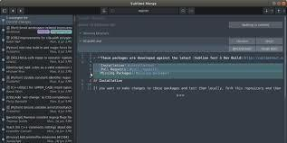

**Fig: Sublime Text**

**JDK:**

A cross-platform software development environment called the Java Development Kit

(JDK) offers a selection of the tools and libraries needed to build Java-based software programmes and applets.. It is a core Java package, along with the JRE and the JVM (Java Virtual Machine) (Java Runtime Environment).

Beginners frequently confuse JRE with JDK, but Java Runtime Environment makes it simple to execute Java apps on your computer if that's all you want to do. However, if you wish to develop a Java-based software programmer, you could also need a few additional required tools, referred to as JDK.

**JRE:**

The free software bundle known as Java Runtime Environment includes a Java classes are including lib and data base server. One of the accompanying Java Development Kit's subsystems is JRE. the most typical setting for running Java programmers on mobile devices. Java byte code is created by compiling Java source code. Without JRE, this bytecode cannot be run on any platform. JRE collects system resources, loads classes, and analyses memory access. JRE serves as an additional operating system layer.

The Java Virtual Machine is made up of the Garçon Virtual Machine and Java Hotspots Customer (JVM). Swing, Java 2D, (AWT), Availability, Image , publish Service, sounds, DnD, and input styles are a few of the interface libraries used by Stoner.

The main libraries Zip, Collections, Concurrency Utilities, services, Java Archive (JAR), tools, Reflection, Vrsn, allows API, Ref Objects, Logging, and Regular Expressions are examples of tools for Lang and Util.

Java for XML Processes, Math, Network, International Support, I/O SAP, Java Stamp size mid, Security, Serialization, and Extension Medium are additional necessary libraries. Additionally included are Java Native Interface (JNI) and Java Management Extensions (JMX) ( XML JAXP).

similar to Web launch, deployment, and Java plug-in deployment technologies

**Database management with My SQL:**

A planned collection of data is called a database. A simple grocery list, a collection of images, or the enormous amounts of data in a business network could all qualify as examples. A database on a computer needs to have data added to it, accessed, and processed using a database operating system like MySQL Garçon. Since computers are actually extremely adept at managing enormous volumes of data, either as an independent activity or as a conduit for other operations, database operation systems play a vital role in computing.

**Relationships in MySQL databases:**

A relational database keeps the data in different tables rather than putting it all in one big stockroom.. Physically lines that are optimized for speed divide up the database structures. The logical model provides an adaptable programming environment and has objects. that are comparable to databases' tables, views, rows, and columns. You design rules that specify how different data fields relate to one another, such as "points" between different tables and requirements for necessary or optional information. These rules are adhered to by the database, which makes sure that your operation never comes across inconsistent, undetected, orphan, outdated, or missed data.

The SQL language is defined by the ANSI/ ISO SQL Standard. Since its inception in 1986, the SQL standard has been utilised in several real-world examples.. The terms "SQL- 92,""SQL1999," and "SQL2003" in this introduction refer to the 1992 standard, the

1999 standard, and the most recent interpretation of the standard, respectively. The term

"SQL Standard" is used to describe the SQL Standard as it is currently understood.

**My SQL Software is Open Source:**

Anyone can use and change the application because it is Open Source. The MySQL software is available for free download from the Internet and can be used by anyone. However, you can search up the original statute and modify it to fit your needs if you so desire. The GPL is mentioned in the MySQL (GNU General Public License) programmed, This covers the many circumstances under which you can and cannot use the application. However, if you are uncomfortable with the GPL or want to incorporate MySQL law into a successful business, you can get a widely accepted interpretation from us.

**SQL feature and benefits:**

SQL is both an easy-to-understand language and comprehensive tool for managing data. Here are some of the major features of SQL and the market forces that have made it successful:

* Vendor independence
* SQL standards
* Multiple view of data
* Relation foundation
* Dynamic data definition
* Complete database language
* Client/server architecture
* Enterprise application support
* Database access and Industry infrastructure

**3.REQUIREMENT AND ANALYSYS**

**Problem Definition:**

• Online book stores are a specialized client need that merges the buying and selling services specifically for their visitors. 

• Reports may be produced instantly, negating the needfora makeshift lab, and analysis can be carried out much more frequently to aid with decision-making. 

• The information on all drug users' books can also be kept up to date because it is frequently required and is genuinely helpful. 

• Enables smokers to register from home and distribute the required goods. 

• We created the "Online Book Store" to solve these issues. 

**System Requirements Specifications:**

A software demand document expresses system conditions. The official statement of what is expected of system formulators is the Software Demand Specification (SRS). The circumstances description and the demand specification are both included in this demand document. A design document is not the software requirement document. It should define what the system should achieve without going into detail about how it should be accomplished. This document's demand is comprehensive and harmonized.

The following requirements are met by the software specification document:

• It outlines the behaviors of external systems.

• It details performance restrictions.

• Change is simple.

• System administrators use it as a reference tool.

• It captures a picture of the system's life cycle.

• General public, guests, and directors are among the user classes and characteristics. 

• The systemallows the general public to view the books, their prices, and the quantityof them that are available.

The books cannot be purchased by unregistered stoners.

• Visitors use the books for browsing and purchasing.

• Clients are also able to provide comments on both books and services

• Directors have the ability to add, edit, and remove books and provide clients with services. The diurnal sale is visible to the director. also has access to the client's feedback.

• the director continuing with the deliveries.

**3.1 Functional Requirements:**

• The system must provide the following features.

• Maintaining a visitor enrolment log.

• Maintaining bookkeeping records.

• Maintaining the daily sell.

• Keeping track of customer feedback.

• Recording information regarding the product, such as whether it was delivered or not.

• Keeping the specifics the client named in the interim warehouse.

**3.2 Non-Functional Conditions:**

Following There will be non-operational conditions at the online shopping gate.

• Secure access to customer information (non-public data).

• A constant vacuum.

• Better performance during peak times thanks to more element design.

Adaptable service For unborn extension, a grounded armature will be quite desirable. System parcels and restrictions are defined by non-functional conditions. Stoner requirements, financial restrictions, organizational programmers, or outside influences like safety laws, student enrolment, and other such things cause it to occur.

Intriguing non-functional requirements include:

1. Security

2. Trustworthiness

3. Maintainability.

4. Mobility

4. Flexibility

6. Reusable

7.Application Compatibility

8.Affinity Resource Utilization

**Requirements for the External Interface:**

**User Interface:**

No feature of the product has a command-line interface; the system stoner will have a graphical user interface.

**4 System Design**

**Data Flow Diagram**

**What is:**

The influx of data or information is depicted in the data flow diagram

(https://pro.smallseotools.com/pricing). Functions may be divided up into separate processes.

Data flow plates can be combined or broken up into different processes. Physical DFDs that depict actual lines and transactions as well as business DFDs are both possible ( logical, or abstract).

**When it's used?**

Judges can communicate effectively by modelling processes and functional situations using the DFD. The likes of Yourdon, McMenamin, Palmer, Gain, and Sea0sonn developed and improved one of the main tools of the structured analytic sweats of the 1970s. It is still regarded as one of the chic modelling approaches for providing inspiration for and portraying the system's processing circumstances.

It's a handy and simple to use modelling tool once acclimated. It operates and is usable with the majority of software development systems. It seamlessly integrates with tools for process modelling, data modelling, and textual specifications. Along with them, it offers judges and innovators reliable models and specifications. It still has a limited utility when used alone. It can be fluidly extended and meliorated with further detail into a physical interpretation for the design and development brigades and is straightforward and simple enough for drug users to understand.

Context plates (Level 0), Partitioned plates (one process only—one place), functionally perished, and level sets of Data Flow plates are the various performances.

**Data Views:**

It serves as a repository for knowledge. This is a representation of a train, table, etc. in the physical model. A data store is a reality or an item in the logical model.

**Low-Level Design (DFD):**

A data flow shortly termed as DFD has the purpose of clarifying system requirements and identifying major transformation that will become programs in system design. So it is the design phase that functionally decomposes requirement specifications down to the lowest level of design. The DFD is also known as data FLOW Graph or Bubble chart.

**DFD Symbols:**

|  |  |
| --- | --- |
|  | Start State |
|  | Data Flow |
|  | Data Process |
|  | Data Store |
|  | Stop State |

**4.1 Data Flows:**

DFDs display how data enters the system from external sources, how it moves through processes, and where it is logically stored. Only four symbols are used.

locations illustrating external realities that serve as data sources or destinations.

with it.

Rounded blocks that depict processes that accept data as input, alter it, and then deal

Arrows signifying the flow of data, which can either be physical or electronic information.

Open-ended blocks that symbolise data stores include both physical stores like filing cabinets or piles of paper and electronic stores like databases or XML lines.

All processes must have at least one data inflow into and one data outflow from, among other common modules.

• Everyoperation should transform the entering data to create fresh varieties of gregarious data.

• At least one data intake must be occurring for each data store.

• A data inflow must be connected to at least one process, and each external reality must be involved with at least one data inflow.

DFDs are nothing more than a network of linked system operations that show the origin and destination of information transfers. The system's beginning point is what breaks down the demand specifications into their smallest positional components.

There are various different and varied DFD symbols. Here are some of them:

External realities are external to the system, but they use the system or force data into it. The forecourt of a cube serves to represent these. A system's external data sources are sometimes referred to as Sources. Cesspools are sometimes used to describe the external realities that utilise system data. Dataflow models depict the system's data transit as lines joined by various systemcomponents. The line is labelled with the name of the dataflow, and an arrow points in the direction of the inflow.

The process shows that the systems do. Each process has one or further data inputs and one or data labour’s. Circles in DFD represent them. Each high position process may be

adhering to multiple lower position processes. The procedure will be expanded in position DFD following. A procedure that converts receiving data input into gregarious data flow is represented as a circle or a bubble.

The highest ranking processes in a system are the following:

the receiving process, the empirical process, and the disposal process.

A data store is a place where data is kept. They include information that is stored in the system. Data can be recovered from the data store by the process or entered into the data store. Data at rest is stored in an open cube.

**4.2 Over view Diagram**

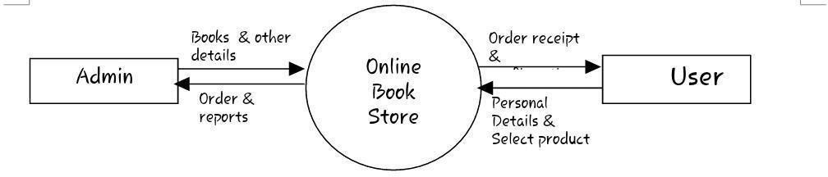**O Level DFD:**

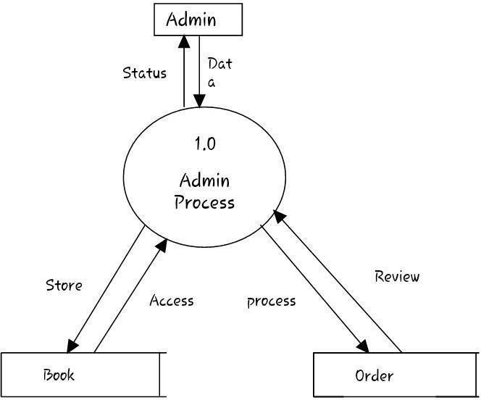**Fig: Setting**

**Fig: DFD for Administrative Process**

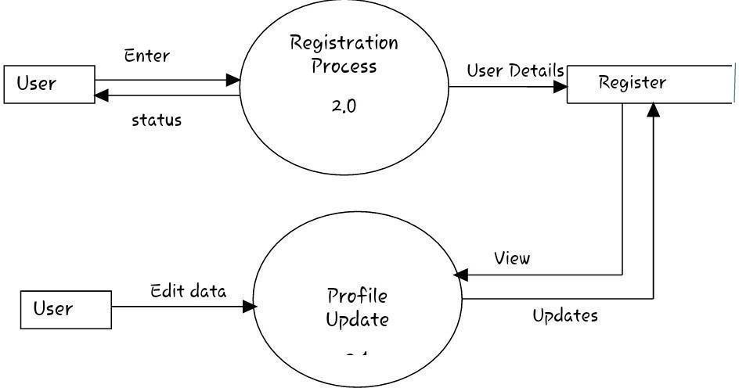

**Fig: DFD for Profile Updates and Registration**

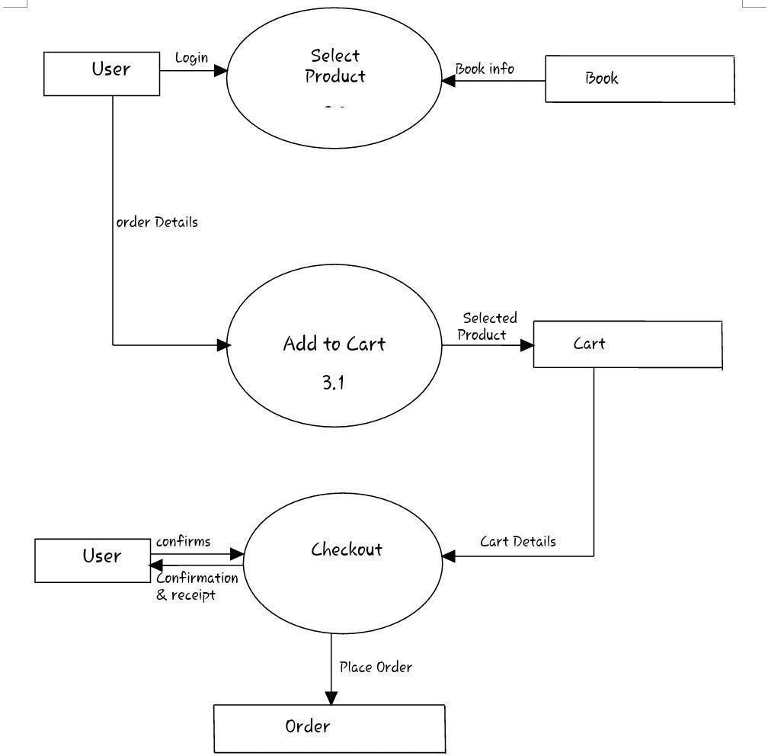

**Fig: DFD for the Checkout and Shopping Process**

**4.3 Entity-Relationship Model:**

The ER model, to put it simply, is an abstract data model that considers linkages and realities in the actual world. The reality-Relationship illustration, which is used to represent data objects visually, serves as an introduction to the model. The model has been expanded since Chen authored his article, and at the moment it is typically used for databases.

**Basic Construct of ER Modelling:**

According to the ER model, the real world is made up of several realities and associations between them.

**Entities:**

Entities are the primary source of debate on the type of data that should be gathered. There are independent and dependent realities (in some methodologies, the terms used are strong and weak, independently). One can define a reality as independent if it doesn't depend on another for identity. A reality that depends on another for identity is said to be dependent.

**Relationships:**

A relationship depicts a connection between two or more entities. Relationships are categorised based on their degree, connectivity, cardinality, and existence.

**Attributes:**

The reality to which they are assigned is described by its attributes. A value is a specific instance of a characteristic. The set of all potential values that a trait might have is known as its sphere. The sphere of Name is a string of characters.

**Classifying Relationship:**

Degree, connectedness, cardinality, direction, type, and actuality are used to categorise connections. Not all modelling techniques employ any of these groups.

**Degree Of Relationship:**

The degree, connectedness, cardinality, direction, kind, and actuality of connections are categorised. All of these groupings are not used by all modelling approaches.

**Connectivity and Cardinality:**

The mapping of related reality cases in a connection is referred to as the relationship's connectedness. There are two types of connectivity: singular and plural. The actual number of connected occurrences for each of the two realities is the cardinality of a relationship. One-to- one, one-to-multitudinous, and multitudinous-to-multitudinous connectedness are the basic categories for relations.

**Directions:**

The trajectory of a connection illustrates how a double relationship is actually developing. Parent reality is the reality where a relationship begins, while kid reality is the reality where a relationship ends.

The type of connection a relationship has affects its course. A related link exists when one of the kid realities also serves as a dependent reality. Both realities coexist in a non- identifying link.

**Existence**:

If a reality case is dependent on the reality of another, related reality case, it is said to be actual. Relationship realities can be classified as either mandatory or consensual.

**Generalization Hierarchies:**

A conception scale is a type of abstraction that says two or more realities can be generalised into a higher position reality type called a supertype or general reality if they share certain characteristics. The subtype, or orders, to the supertype are realities in a lower place. Realitydepending on subtypes.

**4.4ER Notation:**

The introductory ER constructs are represented by label blocks, which stand for realities. The actuality is known as the marker.

• To represent links between two realities, a solid line is employed. The connection's name is written above the line. Relationships should have verbs in their names.

• The reality cube has a list of attributes when they are present. Identifier attributes are denoted byan asterisk (*). Singular nouns should be used for attribute names.

• A line with a crow's foot at the end of it symbolises the cardinality of many. If the crow's bottom is ignored, the cardinality is one, nevertheless.

• A circle or vertical bar placed on the line serves as a representation of reality. The bar (which resembles a 1) indicating that reality is needed for a scenario is obligatory. Placing a circle next to the voluntary reality signifies its voluntariness.

• A circle or vertical bar placed on the line serves as a representation of reality. The bar (which resembles a 1) indicating that reality is needed for a scenario is obligatory. Placing a circle next to the voluntary reality signifies its voluntariness.

**ER Diagram:**

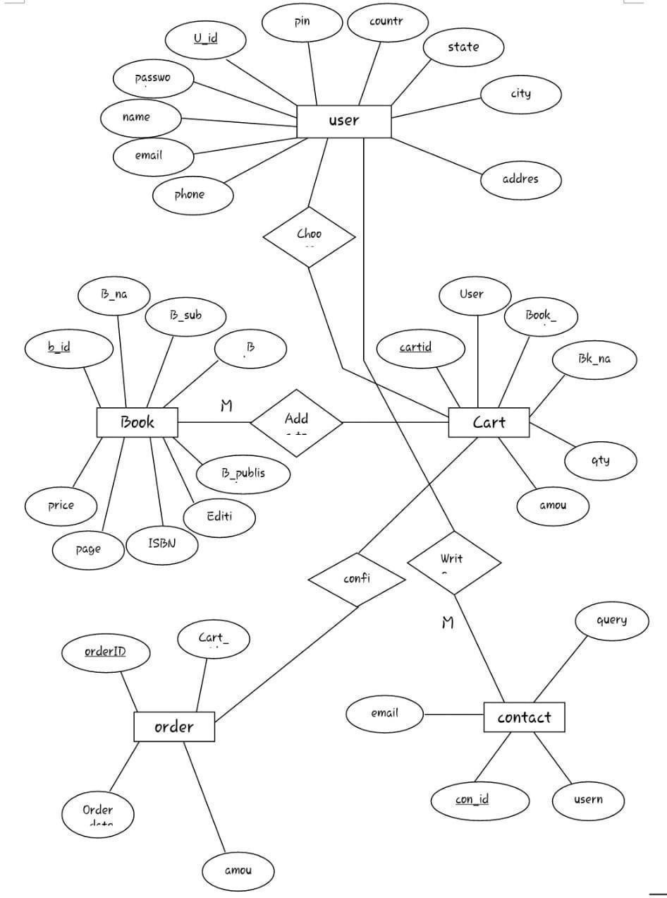

**Fig: ER Diagram**

**SOFTWARE TESTING**

The purpose of the testing strategy is to locate errors in the source code that are contained

inside a function or a unit of work. Testing is the step that is most effective, efficient, and

cost-effective when it comes to identifying flaws in a product. Given the vast number of

different browser versions, the compatibility of the browser has to be maintained in order

to guarantee that the system will display correctly across a broad range of browsers.

Using IE Tester, one may determine how several versions of the Internet Explorer

browser behave on a single computer. installing several user browsers including Firefox,

Google Chrome, and Opera allows for testing of the system. In the end, every single test

was a success.

Unit testing is used to evaluate everything from the fundamental logic to the error

handling, field processing, computations, data handling access, and a variety of possible

inputs and outputs. Cross-field modifications are also tested. Using the application

documentation as a point of reference, the developer examines the code that they have

written in order to verify that all of the specifications and coding standards have been

satisfied. It is recommended that the developer have other people to review their code,

since this is considered to be best practise. All of the program's technical requirements

have to be included into the plans for the unit tests. The internal code, as userll as the

code's inputs and outputs, are the focus of the expected consequences. Unit testing that is

comprehensive and of a high quality will speed up future testing phases by reducing the

percentage of failed tests. The purpose of this test is to validate that every component of

the programme performs as expected.

Unit testing refers to the practise of analysing discrete portions of source code to

determine whether or not they are ready to be implemented. A unit is the name given to

the smallest testable component of a computer programme. Examples of units include

functions, procedures, classes, and interfaces. Unit tests are a kind of test that are often

developed and run by software engineers to ensure that the code they write complies to

the design guidelines and performs as intended. Unit testing is a type of software testing

that aims to separate out each component of the software and demonstrate that each

component is accurate. Unit testing is used to find bugs at an early stage in the

development process. When testing a programme, the objective is not only to find bugs in

the existing software but also to find ways to improve the software's efficiency, accuracy,

and usability. Its primary objective is to evaluate the specifications, functionality, and

performance of a software programme or application.

**Software testing can be divided into two steps:**

i. **Verification:** is the collection of tests and checks that are performed to ensure that

the programme is capable of correctly carrying out a particular function.

ii. **Validation:** This word refers to a number of techniques that make sure the

generated software can be matched to customer requirements. The two most

crucial things to take into consideration while testing the present system are

whether the system properly interprets the user's query and if entities like

numbers, dates, and geographies are acknowledged.

**Software Testing can be broadly classified into two types**:

**Manual Testing:** Without the use of an automated tool or a script, manual testing means

testing software manually. The tester simulates the role of an end user in order to test the

software for any unexpected behaviour or flaws. This testing method is known as "enduser

testing. "Manual testing may be broken down into many different steps, including

unit testing, integration testing, system testing, and user acceptability testing.

**Automation Testing:** Automation testing, which is also known as Test Automation, is

when the tester creates scripts and uses software to test the product. Automation testing is

also referred to as Test Automation. A formerly manual process will now be taken care of

by this automated technique. The purpose of automation testing is to quickly and

repeatedly perform test scenarios that user are previously executed manually in the

context of manual testing.

**Testing strategies**

As part of the process of verifying software, software testers conduct evaluations of

various software products. Before providing the finished product, developers are

responsible for ensuring that the system or product has been tested, as user as for

performing analysis and verifying procedures. In addition, they are tasked with delivering

the final product on time. Only the user is subject to verification and validation since their

satisfaction with our product is of the utmost importance to us. Validation is necessary

before a product can be put on the market so that its merits and downsides may be

assessed. In addition, useful for the subsequent improvements and advancements

**i. Unit testing**

Unit testing refers to the practise of analysing discrete portions of source code to

determine whether or not they are ready to be implemented. The smallest testable

component of a programme, such as functions, procedures, classes, and interfaces, is

called a unit. Unit tests are a kind of test that are often developed and run by software

engineers to ensure that the code they write complies to the design guidelines and

performs as intended .Here the problems are identified by the developers before the

launch of the application. Unit testing aims to separate out each component of the

software and demonstrate that each component is accurate.

ii. **Integration testing**

Integration testing in the software testing model comes before system testing and after the

unit testing has been done. Integration testing is performed by first gathering all of the

individual modules that have successfully passed the earlier step of unit testing and then

incorporating each individual module into a larger group. The integration testing stage

will ensure that any problems, such as mistakes or defects, caused as a result of the

integration of the modules are eliminated when the modules are being merged. This will

be done while the integration testing step is being performed.

Testing for integration is not concerned with the overall integration of the system;

rather, its focus is on the integration of individual processes inside the system. In the

process of integration testing, three things are produced: a test plan, test cases, and test

data. These three items are produced to ensure that the integration of the modules is

successful, as user as the successful operation of the system. Integration testing is

performed in order to assess the interaction that occurs user the many platforms that are

necessary to collaborate with one another in order to carry out a single task.

iii. **Functional Testing**

Functional testing will provide a demonstration of the capabilities that are being

evaluated, in addition to meeting the client's various commercial and other requirements.

It will utilise the level of pleasure experienced by customers as a foundation for verifying

the input and output provided by use

Certified Car Price Prediction 75

**iv. System Testing**

During system testing, the product is examined to see whether or not it functions in a

manner that is consistent with our standards .After that, user mostly rely on functional and

system testing to guarantee that the final product satisfies the requirements outlined by

our organisation. Testing inside a controlled environment Testing of this kind occurs

when the tester is fully conversant with the integration and design of the application being

tested. It is used to perform testing in regions where the conventional techniques are

either unavailable or difficult to utilise.

**v. White box testing**

It is type of testing where tester know every single aspect of the application design and

integration. It is used to perform test on the regions where usual methods cannot be used

or not available.

**vi. Black Box Testing**

Testing in a black box is open to anybody. since its completion is not necessary for the

project to continue. During this testing, it is essential that both the user demand and the

specification be adhered to. If no one is acquainted with the flow of the project and they

are unable to do black box tests, then they are required to give a comprehensive report

that details all of the testing activities.

**5.Detailed Design**

**Introduction:**

The result of a "how to" approach for creating a new system is systemdesign. It is made up of several ways. It makes the feasibility study's system recommendations easier to grasp and gives the procedural information needed to implement it. The importance of rewording the performance requirements into design specifications is emphasized. The conceptual and physical steps of design development are included.

Reviewing the current physical system, creating input and affair specifications, editing, security and control specifications, outlining the perpetration plan, and creating a logical design walkthrough are all steps in the logical design process. The physical design describes hardware and software, plans the system's execution strategy the physical system's characteristics are mapped out. The system design transforms system as suggested by the feasibility study, demand into the system's procedures. The system design is thus a reiteration of a document that a programmer or database professional is already familiar with. The following elements, which are fundamentally creative in nature, can greatly help the system design process

• A visual representation of the existing system

• A list of the future system's requirements

**Modules Description:**

1. The customer can register an account before continuing to shop.

2. The administrator can add books, review orders to ensure prompt delivery, and validate guest payments.

3. After logging in, guests can explore the various books, select one or more items, and add them to their shopping cart.

4. Installation is available with Cash on Delivery as payment.

**5.1 Input Design:**

A significant portion of the entire system design that required extremely careful consideration was the input design. Specific guidelines had been followed in order to make data entry as simple, logical, and error-free as feasible. The system's confirmation checks stopped a stoner from inputting inaccurate, inaccurate data. As a result, only trustworthy data had been made available for data processing. However, if acceptable data was supplied, it was also encouraged to enter accurate data by means of relevant error broadcasts. The formats of the interactive screens facilitate the entering of accurate data.

**5.1.1 Validation:**

Some fields solely contain numbers, such as an IP address. ASCII is evaluated for this significant matter. If they entered characters, the message requesting only numeric input would be displayed. The presence of numeric and fleck symbols will be checked in the exchange rate field.

**5.1.2 Input Design Goals:**

**Input design's primary goals are to:**

• Create an affordable input system.

• Ensure that input is respectable to and understandable by the stoner staff.

• Achieve the highest level of delicacy.

Affair generally refers to the data and information that the system generates, as you probably already know.. Affair is the primary driver for the development of the system and the foundation for many end-users' assessments of the operation's usefulness. Most extreme drug users will use the system's functionality without actually operating it or entering data through workstations.

• When creating mechanism for an affair, judges must discuss the following.

• Select the information to be presented; • Choose the information's presentation method—display, publication, or "speaking"

• Plan the information contribution in a reputable manner.

Layout is defined as the arrangement of information on a display or in a published document. Negotiating the broad guidelines outlined above will result in particular viewpoints, example as choosing whether to generate reports and papers using preprinted forms, deciding whether to utilise plates and colour, or how many lines to include on a printed runner. The arrangement and purposes of the affair's design are described., wastes that detail position attributes, andthe arrangement of the pagination and column headings. These fundamentals are comparable to an architect's blueprint, which shows where each component is located, as we mentioned atthe beginning of this article.

**5.3 Data Base Design:**

The management of information as a whole is the primary function of a database. A database is a set of interconnected data that is sparsely redundantly kept and can be used to efficiently and swiftly serve lone drug consumers. Making information for stoners necessary, quick, affordable, and flexible is the aim.

**User Table:**

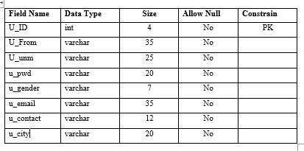

**Category Table:**

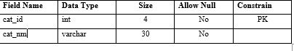

**Subcat Table:**

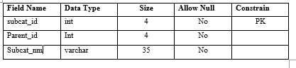

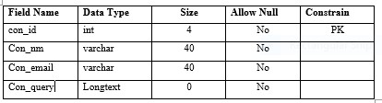

**Book Table:**

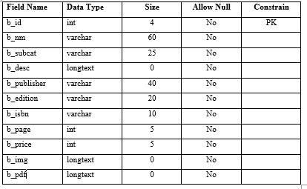

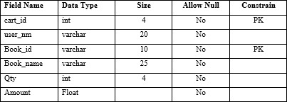

**Checkout Table**

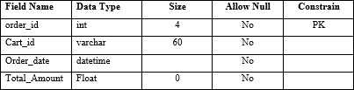

**6.IMPLEMENTATION AND TESTING**

**A screenshot**



**Fig : First Page**

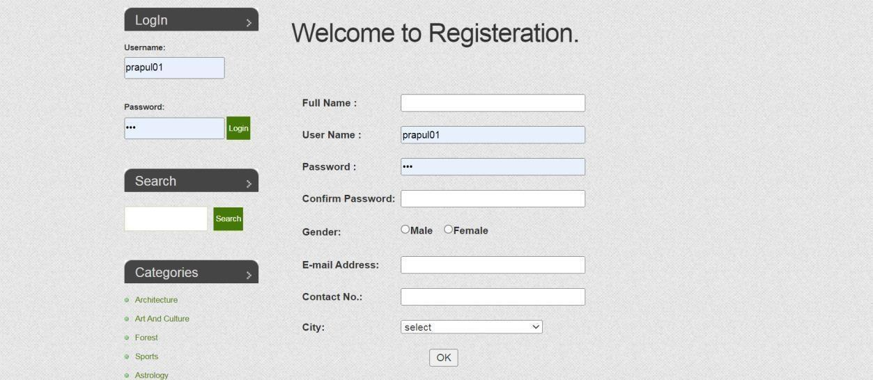

**Fig: Registration page**

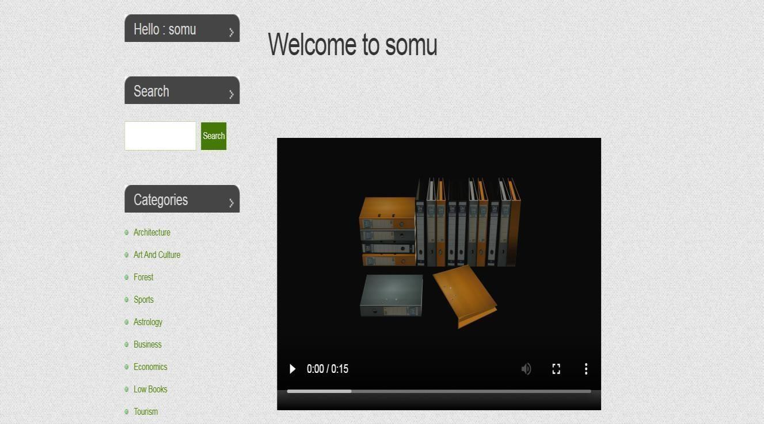

**Fig :Obtain Page**

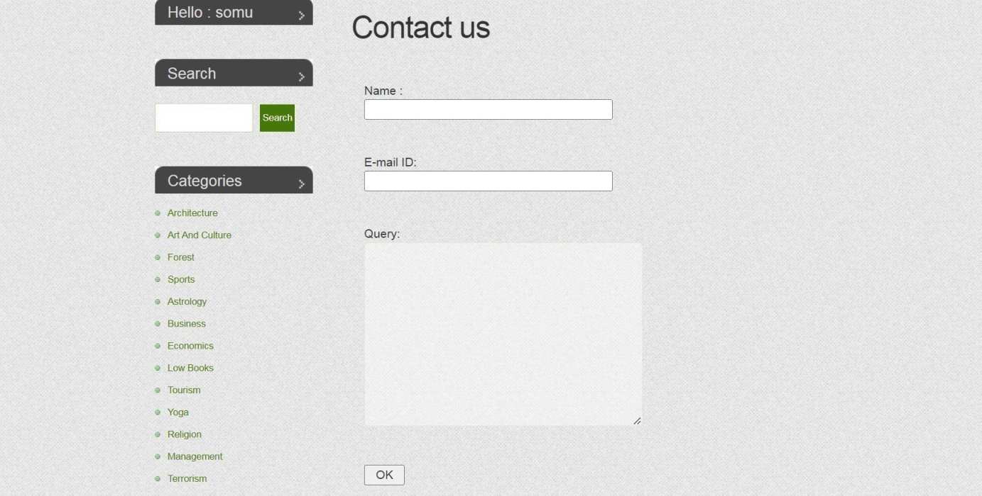

**Fig : Contact Us Page**

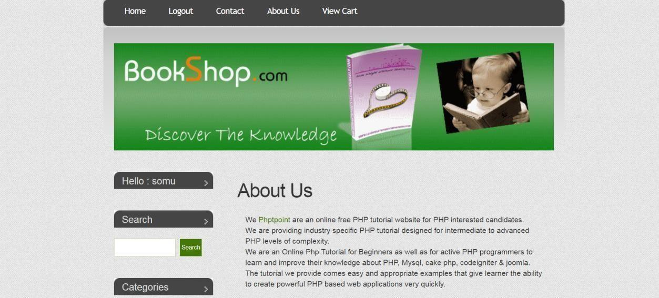

**Fig :Our Story Page**

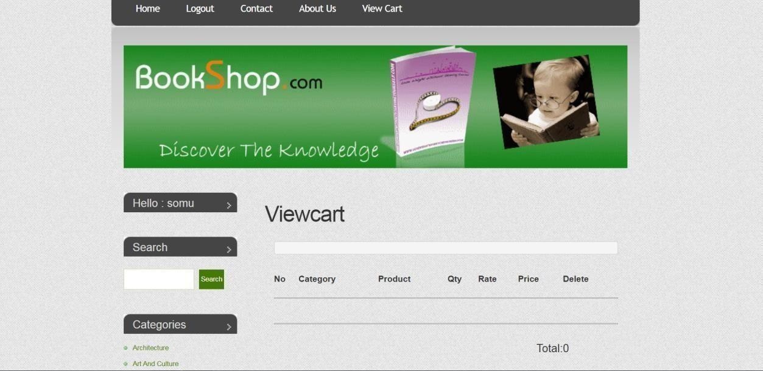

**Fig : View Page of Cart**

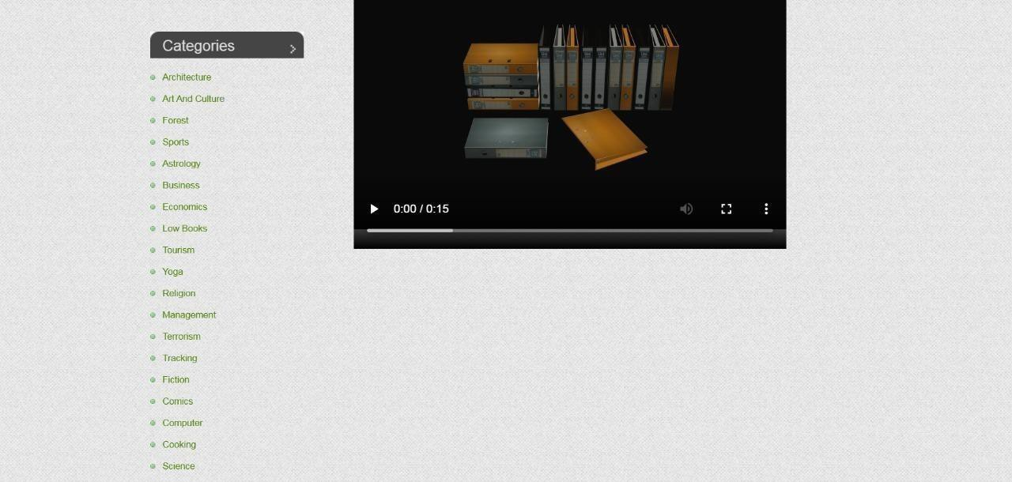

**Fig : Categories of Books**

**Categories of Books:**

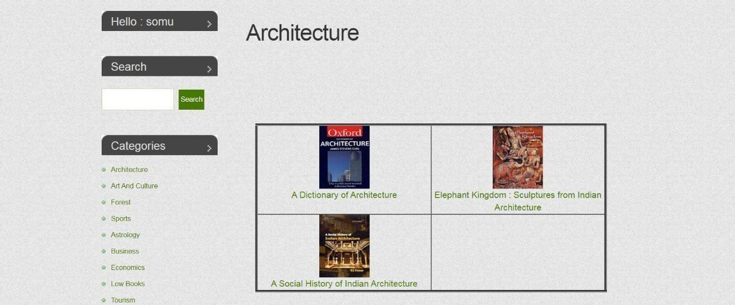

**Fig : View to Architecture book**

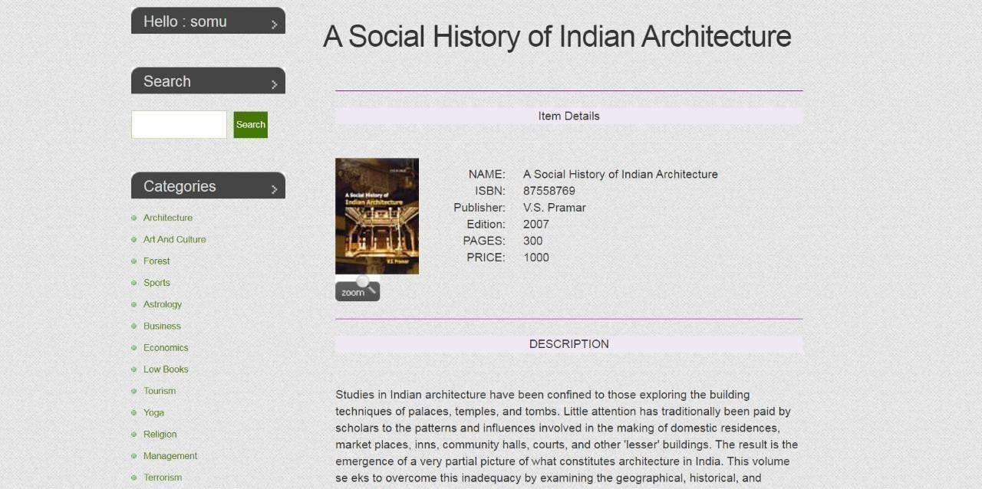

**Fig : Architecture book description**

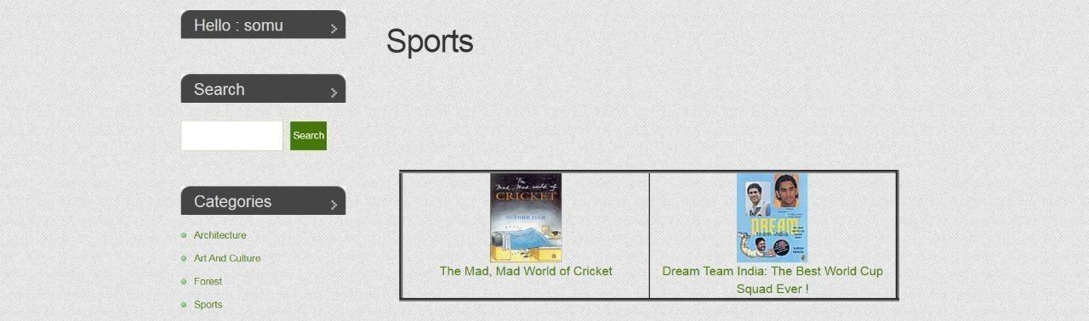

**Fig : :Sports Books**

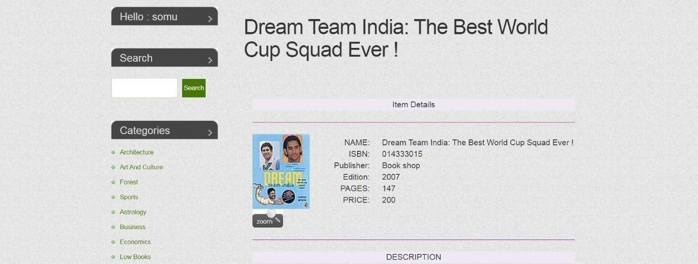

**Fig : Description of Sports Books**

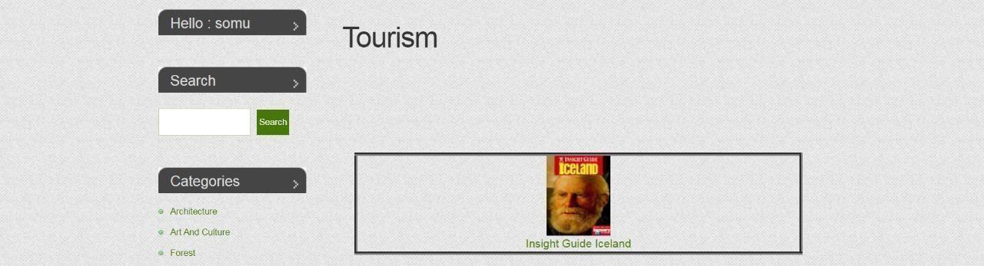

**Fig : Tourism Book**

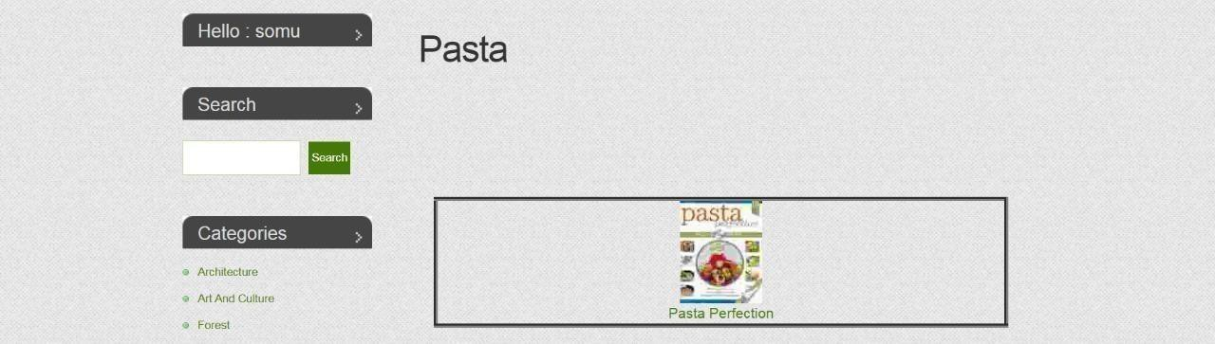

**Fig : Food Making Book**

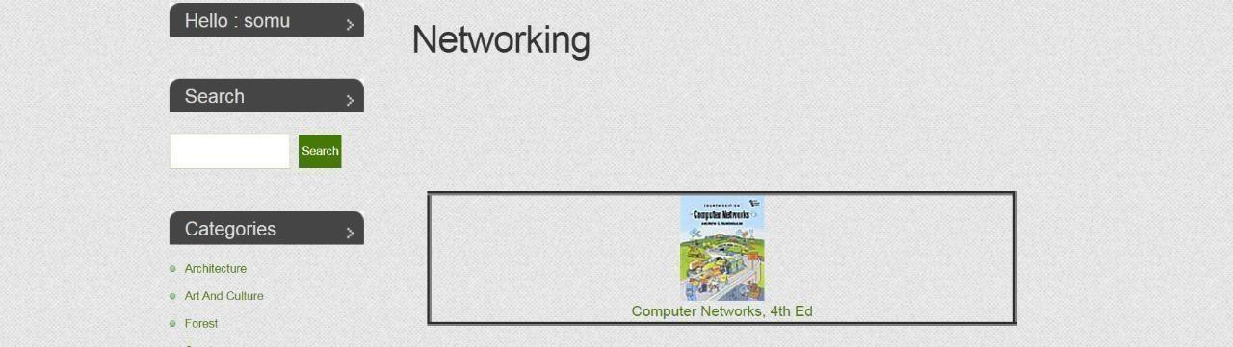

**Fig : Networking Book**

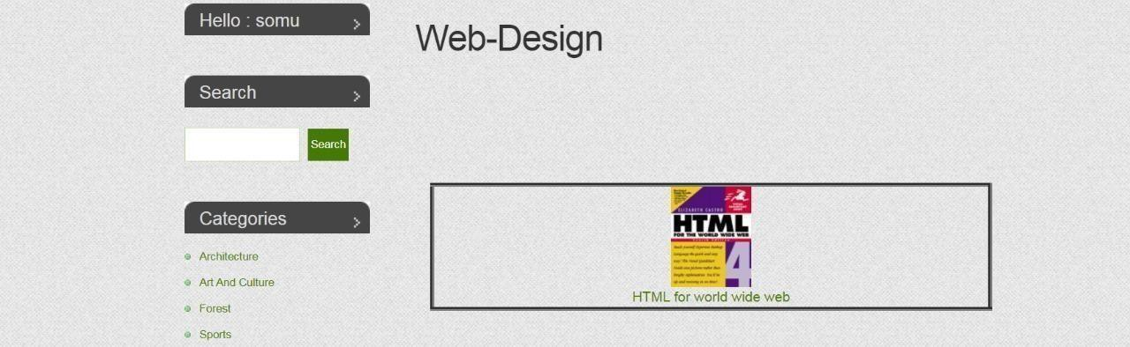

**Fig : Web designing Book**

:

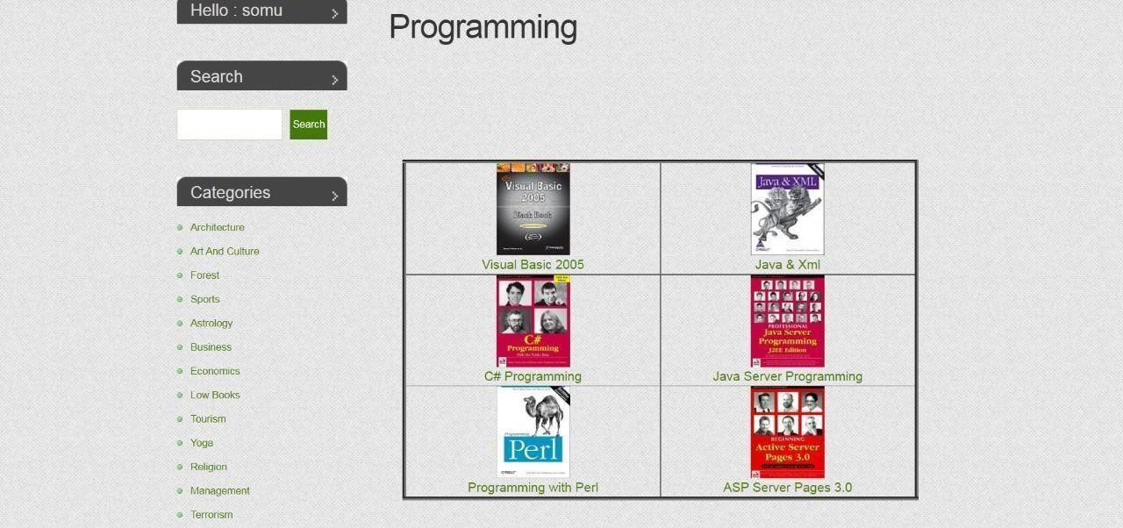

**Fig : Programming Language Book**

**7.1 Conclusion:**

**7.CONCLUSION**

• The creation of an online book store is the goal.

• Allow online book purchases by drug users.

• Make it simple to locate the necessary alternative handbook.

• less time is spent.

• The main focuses of this project are communication and a user-friendly online portal.

**7.2 Limitations:**

* Customers are required to purchase books even when they cannot see them in person.

Alternative handbooks are not organized according to oldest data.

* It can have a mistake compared to the previous edition.
* It needs internet connection all time

**7.3 Feature Scope of Projects:**

• Customers can look up delivery options

• An application or piece of software will be made.

• A section for feedback will be created.

• Customers may also sell books on our website. the latest edition

**8. BIBLIOGRAPHY**

1. This is a primer on the murarchialm in HTML and CSS, California 2012, p. 4 Mike Murach and Associates, Inc. 7. Boehm, A., and Ruvalcaba, Z.
2. E. Cosper (2035, August 4) USA: Irvine, California
3. E.L.Tompson and E.Mayer's Unified Modeling Language in
4. PHP6Software Engineering Book
5. Software Testing book
6. DBMS book
7. CSS book

**8.1 Website**

1. [www.c#corner.com](http://www.c#corner.com)
2. [http://pragimtech.com](http://pragimtech.com/)
3. [www.stackoverflow.com](http://www.stackoverflow.com)
4. [www.aspsnippets.com](http://www.aspsnippets.com)